**FIRST FASHION**

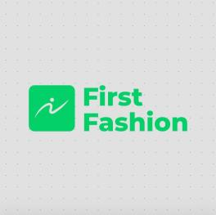 **FIRST FASHION**

Address:Alagbole , Ogun State, Nigeria.

Shopping at **First Fashion** brings you numerous benefits and the highest quality in the fashion world.

Discover what you can find on our website:

Trendsetters' Selection

Explore the latest trends and handpicked fashion pieces. Our collections are curated for style enthusiasts looking for the most up-to-date fashion statements.

Variety and Versatility

Our website offers a wide range of fashion items, from clothing and accessories to shoes and more. Whatever your style, you'll find the perfect outfit.

Quality and Craftsmanship

We believe in offering premium quality fashion. Our products are crafted with attention to detail and are built to stand the test of time.

Style Fit for You

No matter your taste, our website caters to all styles and preferences. Find the fashion pieces that truly express your individuality.

Easy Navigation

Our user-friendly interface ensures a seamless shopping experience. Browse and shop effortlessly through our extensive fashion collections.

Reviews and Ratings

Get insights from our fashion-savvy community. Read and leave reviews to help others make informed fashion choices.

Secure Shopping

Shop with confidence, knowing your personal information and payment details are always protected.

Shipping and Returns

We provide hassle-free shipping and a flexible return policy for your convenience.

Style Tips and Inspiration

Explore our blog section for style tips, trends, and fashion inspiration to elevate your wardrobe.

**First Fashion** offers all these features with a satisfaction guarantee. With an array of choices to select from, our website simplifies the world of fashion for every customer, whether you're a seasoned trendsetter or a fashion novice.